Sensor Boards Assembly Instructions

Bellevue Satellite Club

Written by Dan Ruder, 1/31/2015

danruder@outlook.com

# Introduction

These instructions will help you correctly assemble three sensor boards (temperature and humidity, light, and UV light). When completing the steps in the *Assembly Order* sections, please refer to the figures as necessary. The end of this document contains nstructions for crimping Molex modular connectors.

# Tools & Materials

Soldering iron

Mini wire cutters

Small needle-nose pliers

Mini vise or helping hands holder

Lead-free rosin core solder

Crimper for Molex KK modular connectors

All the parts for the boards

# General Instructions

* If you are not sure how to solder, please see the [EEVBLOG #183](https://www.youtube.com/watch?v=fYz5nIHH0iY), Soldering Tutorial Part 2 on YouTube.
* When soldering components, work from the inside to the outside, short components to tall components. This will help ensure you have room to solder each component.
* Place one or two components on the top side of the board, noting the orientation of each component; then turn the board over and solder these components in place. You may need to tape the components in place with masking tape.
* Try to position the components close to the board and them pointing straight up when you solder them so they are neat and protected from damage during use.
* If you are using lead-free solder, set the soldering iron temperature to approximately 350-375 degrees C. If you are using leaded solder, set the soldering iron temperature to 325-350 degrees C.

**Tip:** to solder a pin, place a little solder on the tip of the iron to promote heat transfer, then place the tip of the iron on the pad and the pin. Apply solder to the pad and pin and it should melt down into the hole, filling the hole and leaving a short volcano-shaped bit of solder around the pin. If you get a round blob of solder around the pin, you have applied too much solder and likely did not heat the pin and the pad.

* Check the solder joins on all of the pins on both sides of the board. If any joint is mal-formed, heat the pad and it should reflow the solder into the hole. Once the joint is correct, clip the leads just above the solder.
* Solder one to a few components at a time so that the leads don’t get in the way when you are soldering.
* When soldering the IC sockets, alternate soldering pins on opposite sides of the socket to give each pin a chance to cool down. This prevents overheating of the board and the plastic IC socket.

# Temperature and Humidity Sensor Array

This board hosts two sensors: a TMP36 analog temperature sensor and a HIH-4020-002 analog humidity sensor. The temperature sensor can be used by itself without the humidity sensor because air temperature does not depend on relative humidity. However, if you use the humidity sensor, then you must also use the temperature sensor because calculating the relative humidity of air is dependent on temperature. **Research question**: how is relative humidity dependent on temperature?

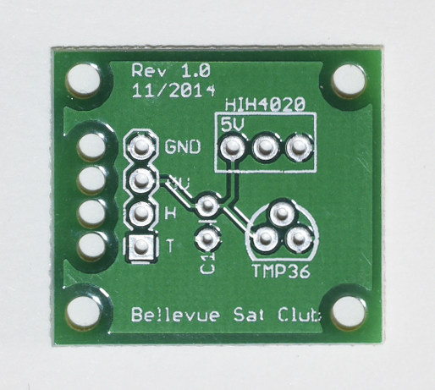

Figure 1 Top view temp & humidity sensor PCB

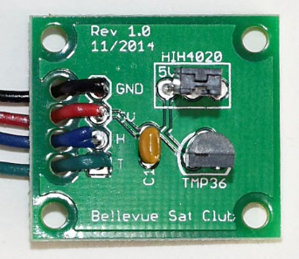

Figure 2 Assembled sensor array

## Assembly order

1. Solder the **0.1 uF capacitor** into the two holes marked **C1** on the board. The orientation does not matter.
2. Solder the 3-pin TMP36 temperature sensor, noting the flat surface of the TMP36 must match the flat side of the outline printed on the board. To get the TMP36 to sit nicely next to the board, it helps to bend the pins carefully to match the holes before inserting it. As you insert it, wiggle it very slightly and the bottom of the TMP36 should sit 3-4mm above the surface of the board.
3. If you are using the humidity sensor, solder it to the board. **Be sure to align it correctly before soldering it.** The humidity sensor has two flat sides; one with two circular holes and one that is plain. When you are looking straight at the side with the two holes, the **right pin is the 5V pin** and must be inserted into the hole on the board marked **5V**. When the humidity sensor is correctly inserted, the two holes will be facing away from the TMP36.
4. Strip **3 mm** from the one end of each of the colored wires (red, black, blue, green), then twist the strands with your fingers to form a tight bunch. The color of each wire will match a specific pair of holes on the left side of the board.
   1. **Blue** wire to the hole marked **H** (humidity) only if you are using the humidity sensor
   2. **Red** wire to the hole marked **5V** (5V power)
   3. **Black** wire to the hole marked **GND** (ground)
   4. **Green** wire to the hole marked **T** for (temperature)
5. One at a time, push a colored wire up from the bottom of the board through the large hole, then push the bare end of the wire down the corresponding hole with pad and solder it into place. Do the same for each wire. Be careful not to burn the wires by touching them with any part of the soldering iron.
6. Create a crimped connection for each of the colored wires. This is a multi-step process that must be performed carefully to get a strong connection. Follow the steps in the **Wire Crimping Instructions** later in this document.

**STOP HERE! HAVE YOUR CRIMPED WIRES**

**CHECKED BY AN ADULT**

1. Insert the connectors into the 3-pin plastic housings. You will need two housings for this step; one for the temperature sensor and one for the humidity sensor if you’re using one. The order of which wires go into which holes in the housing and the orientation of the connector with respect to the hole in the housing are both important.

The 3-pin housings are designed to match the 3-pin headers on the Flight Controller board. The connectors are polarized so they can be inserted only one way: the bottom of the housing has two little tabs that fit the plastic riser on the header.

The tops of the holes in the housings also have a little notch, and the flat side of the housing has three little slots. The connectors have a spring loop on their front sides and a little catch on their back sides. The little catch goes into the side with the little notch and the slots.

Hold the housing so that the flat side with two little tabs at the bottom is facing you. Gently insert the three wires, one at a time, until they snap into place:

* 1. **Black** wire in the **left** hole, with the loop facing you.
  2. **Red** wire in the **middle** hole, with the loop facing you.
  3. **Green** wire in the **right** hole, with the loop facing you.
  4. Gently tug on each wire to see that it remains locked in the housing.

1. If you are using the humidity sensor, hold the second housing in the same manner as the first. Then, insert **blue** wire in the **right** hole, with the loop facing you. Press down gently until it snaps into place. Gently tug on the wire to see that it remains locked in the housing.

**CONGRATULATIONS! YOU HAVE FINISHED ASSEMBLING**

**THE TEMPERATURE / HUMIDITY SENSOR BOARD!**

# Analog Light Sensor

This board hosts a log-scale analog light sensor. The only assembly is to connect the three wires to the board and then connect the other ends of the wires to a modular connector.

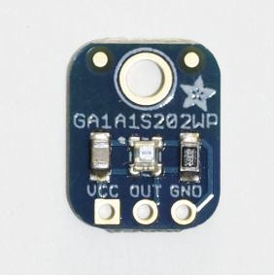

Figure 3 Analog light sensor

## Assembly order

1. Strip 3 mm from the one end of each of the colored wires (red, black, green), then twist the strands with your fingers to form a tight bunch. The color of each wire will match a specific pair of holes on the left side of the board.
   1. **Green** wire to the hole marked **Out** (data output)
   2. **Red** wire to the hole marked VCC (5V power)
   3. **Black** wire to the hole marked **GND** (ground)
2. One at a time, push the bare end of a colored wire up from the bottom of the board through its matching hole and solder it into place. Do the same for each wire. Be careful not to burn the wires by touching them with any part of the soldering iron.
3. Create a crimped connection for each of the colored wires. This is a multi-step process that must be performed carefully to get a strong connection. Follow the steps in the **Wire Crimping Instructions** later in this document.

**STOP HERE! HAVE YOUR CRIMPED WIRES**

**CHECKED BY AN ADULT**

1. Insert the connectors into a 3-pin plastic housing. You will need one housing. The order of which wires go into which holes in the housing and the orientation of the connector with respect to the hole in the housing are both important.

The 3-pin housings are designed to match the 3-pin headers on the Flight Controller board. The connectors are polarized so they can be inserted only one way: the bottom of the housing has two little tabs that fit the plastic riser on the header.

The tops of the holes in the housings also have a little notch, and the flat side of the housing has three little slots. The connectors have a spring loop on their front sides and a little catch on their back sides. The little catch goes into the side with the little notch and the slots.

Hold the housing so that the flat side with two little tabs at the bottom is facing you. Gently insert the three wires, one at a time, until they snap into place:

* 1. **Black** wire in the **left** hole, with the loop facing you.
  2. **Red** wire in the **middle** hole, with the loop facing you.
  3. **Green** wire in the **right** hole, with the loop facing you.
  4. Gently tug on each wire to see that it remains locked in the housing.

**CONGRATULATIONS! YOU HAVE FINISHED ASSEMBLING**

**THE LIGHT SENSOR BOARD!**

# Analog UV Light Sensor

This board hosts an analog ultraviolet (UV) light sensor. The only assembly is to connect the three wires to the board and then connect the other ends of the wires to a modular connector.

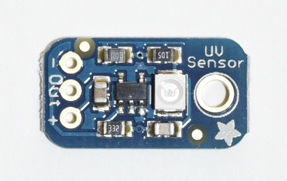

Figure 4 Analog UV light sensor

## Assembly order

1. Strip 3 mm from the one end of each of the colored wires (red, black, blue), then twist the strands with your fingers to form a tight bunch. The color of each wire will match a specific pair of holes on the left side of the board.
   1. **Blue** wire to the hole marked **Out** (data output)
   2. **Red** wire to the hole on the right side marked **+** (5V power)
   3. **Black** wire to the hole on the left side marked **-** (for ground)
2. One at a time, push the bare end of a colored wire up from the bottom of the board through its matching hole and solder it into place. Do the same for each wire. Be careful not to burn the wires by touching them with any part of the soldering iron.
3. Create a crimped connection for each of the colored wires. This is a multi-step process that must be performed carefully to get a strong connection. Follow the steps in the **Wire Crimping Instructions** later in this document.

**STOP HERE! HAVE YOUR CRIMPED WIRES**

**CHECKED BY AN ADULT**

1. Insert the connectors into a 3-pin plastic housing. You will need one housing. The order of which wires go into which holes in the housing and the orientation of the connector with respect to the hole in the housing are both important.

The 3-pin housings are designed to match the 3-pin headers on the Flight Controller board. The connectors are polarized so they can be inserted only one way: the bottom of the housing has two little tabs that fit the plastic riser on the header.

The tops of the holes in the housings also have a little notch, and the flat side of the housing has three little slots. The connectors have a spring loop on their front sides and a little catch on their back sides. The little catch goes into the side with the little notch and the slots.

Hold the housing so that the flat side with two little tabs at the bottom is facing you. Gently insert the three wires, one at a time, until they snap into place:

* 1. **Black** wire in the **left** hole, with the loop facing you.
  2. **Red** wire in the **middle** hole, with the loop facing you.
  3. **Blue** wire in the **right** hole, with the loop facing you.
  4. Gently tug on each wire to see that it remains locked in the housing.

**CONGRATULATIONS! YOU HAVE FINISHED ASSEMBLING**

**THE UV LIGHT SENSOR BOARD!**

# Wire Crimping Instructions

The polarized locking headers form a secure connection, but require the ends of the wires to be crimped and soldered to small metal connectors. This may seem challenging at first because of the small sizes, but if you follow these instructions carefully, you will make solid connections.

1. Cut all wires to the same length. The easiest way to do this is to line up all of the wires next to each other with your fingers, then trim the minimum amount from ends with one cut.
2. Do all of the following steps for one wire at a time; this will ensure the connectors don’t slip off the ends of the wires before they are soldered.
   1. Strip 2-3 mm (but not more than 3mm) from the end of the wire and twist the strands together with your fingers to form a tight bunch.
   2. Lay the end of the wire into the channel of the connector. The connector has two sets of tabs; the tabs on the end of the connector are designed to hold the end of the colored wire insulation and the tabs in the middle are designed to hold the ends of the bare wire. The end of the insulation should be just barely past the first tab and the bare wires should be just barely past the end of the second tab.
   3. Use needle-nose pliers to slightly bend the first tabs around the insulation; this will hold the wire in the connector so it can be crimped with the crimping tool.
   4. Use the crimping tool to crimp the first tabs tightly around the insulation on the wire. Put the tabs toward the notch labelled 22-26 in the crimping tool. Squeeze the crimper tightly. Then, slide the crimping tool over the second set of tabs and crimp the second set of tabs around the bare ends of the wire.
   5. Check that both sets of tabs have been crimped tightly; the first set of tabs around the insulation and the second set around the bare wire. Don’t pull on the wire or the connector!
   6. If you are using 26-gauge wire, use the crimping tool to crimp both sets of tabs a second time to make them tighter. This time place the tabs toward the notch labelled 26-28 in the crimping tool. Squeeze tightly.
   7. Check that both sets of tabs have been crimped tightly; the first set of tabs around the insulation and the second set around the bare wire. Pull gently on the wire or the connector.
   8. Solder the wire to the crimper with a small amount of solder. Keep the solder from getting all over the outside of the connector or else the connector won’t fit into the white plastic housing. Once this has cooled, visually inspect the solder joint to make sure both crimper and wire are joined. Pull gently on the wire and the connector to make sure the connector doesn’t come off the wire.

After crimping all of your wires, perform continuity test with the connectors and the other ends of the wires. Re-crimp any wires that don’t have continuity; you will need to cut off the connector and get a new one.